**ET300 GPS Tracker Configuration**

1. step 1, your computer have to install with our driver (USB_Driver_PL2303_Win8)
2. step2, connect your device with USB to computer, but remember device don't power on
3. step3,open our update software

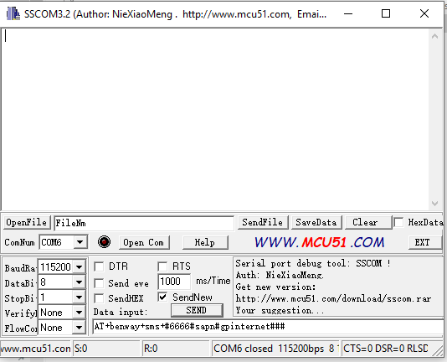

1. then open Com

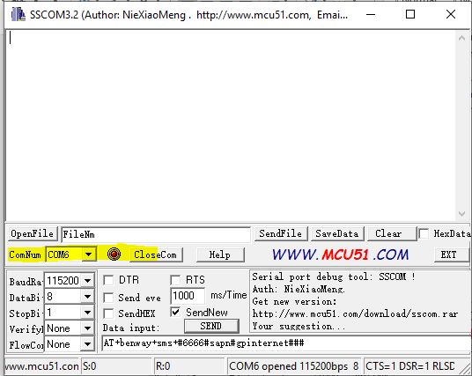

6.

then turn on the power(GPS Tracker)

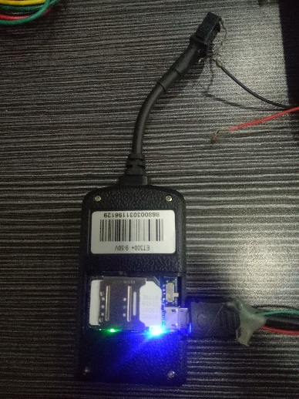

7. then fillin your parametes inside the blank list,then click its beside number

IP SET: AT+benway+sms+#6666#IP#182.163.112.219#6090#

APN Set: AT+benway+sms+#6666#sapn#gpinternet###

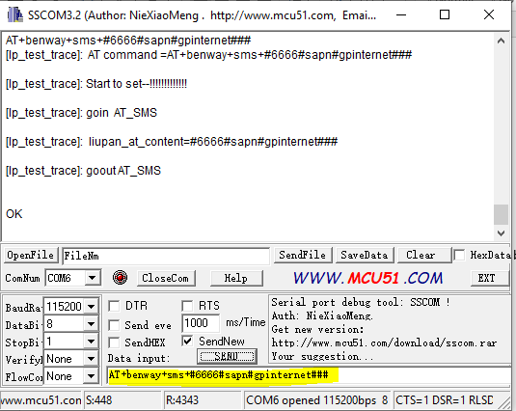

9. remember don't remove USB,just turn off the device's power

10. then after several seconds,then power on

11. Check and then

please close COM,then close software

then remove the device

then put simcard inside test

